 LEARN / PLAY FOR CHILDREN WITH DISABILITY

**A PROJECT REPORT**

***Submitted by***

**AKSHAYA MATHI D (2303811723422012) ARUNA KJ (2303811724322015)**

**DEVADHARSHINI J (2303811724322022)**

**DEVADHARSHINI K (2303811724322023)**

***in partial fulfillment of requirements for the award of the course***

**AGB1211 – DESIGN THINKING**

***in***

**ARTIFICIAL INTELLIGENCE AND DATA SCIENCE**

**K. RAMAKRISHNAN COLLEGE OF TECHNOLOGY**

(An Autonomous Institution, affiliated to Anna University Chennai and Approved by AICTE, New Delhi)

**SAMAYAPURAM – 621 112**

**DECEMBER, 2024**

# K. RAMAKRISHNAN COLLEGE OF TECHNOLOGY (AUTONOMOUS)

**SAMAYAPURAM – 621 112**

# BONAFIDE CERTIFICATE

Certified that this project report on **“LEARN / PLAY FOR CHILDREN WITH DISABILITY”** is the bonafide work of **AKSHAYA MATHI D (2303811724322012), ARUNA KJ (2303811724322015), DEVADHARSHINI J**

**(2303811724322022), DEVADHARSHINI K (2303811724322023)** who carried

out the project work during the academic year 2024 - 2025 under my supervision

**Signature Signature**

Dr. T. AVUDAIAPPAN M.E.,Ph.D., Mrs. S. GEETHA M.E

**HEAD OF THE DEPARTMENT, SUPERVISOR,**

Department of Artificial Intelligence, Department of Artificial Intelligence,

K. Ramakrishnan College of Technology, K. Ramakrishnan College of Technology, Samayapuram, Trichy -621 112. Samayapuram, Trichy -621 112.

Submitted for the viva-voce examination held on 5.12.24

**INTERNAL EXAMINER EXTERNAL EXAMINER**

# DECLARATION

I declare that the project report on “**LEARN / PLAY FOR CHILDREN WITH DISABILITY"** is the result of original work done by us and best of our knowledge, similar work has not been submitted to “**ANNA UNIVERSITY CHENNAI**” for the requirement of Degree of **BACHELOR OF TECHNOLOGY**. This project report is submitted on the partial fulfillment of the requirement of the award of the **AGB1211**

**– DESIGN THINKING.**

**SIGNATURE AKSHAYA MATHI D**

**----------------------------- ARUNA KJ**

**----------------------------- DEVADHARSHINI J**

**----------------------------- DEVADHARSHINI K**

**----------------------------**

**Place:** Samayapuram

**Date:** 5/12/2024

**ACKNOWLEDGEMENT**

It is with great pride that I express our gratitude and indebtedness to our institution, **“K. Ramakrishnan College of Technology (Autonomous)”,** for providing us with the opportunity to do this project.

I extend our sincere acknowledgement and appreciation to the esteemed and honourable Chairman, **Dr. K. RAMAKRISHNAN, B.E.,** for having provided the facilities during the course of our study in college.

I would like to express our sincere thanks to our beloved Executive Director,

**Dr. S. KUPPUSAMY, MBA, Ph.D.,** for forwarding our project and offering an adequate duration to complete it.

I would like to thank **Dr. N. VASUDEVAN, M.TECH., Ph.D.,** Principal, who gave the opportunity to frame the project to full satisfaction.

I thank **Dr.T.AVUDAIAPPAN, M.E.,Ph.D**., Head of the Department of

**ARTIFICIAL INTELLIGENCE AND DATA SCIENCE**, for providing her

encouragement in pursuing this project.

I wish to convey our profound and heartfelt gratitude to our esteemed project guide

**Mrs.S.GEETHA M.E**., Department of **ARTIFICIAL INTELLIGENCE AND**

**DATA SCIENCE**, for her incalculable suggestions, creativity, assistance and patience, which motivated us to carry out this project.

I render our sincere thanks to the Course Coordinator and other staff members for providing valuable information during the course.

I wish to express our special thanks to the officials and Lab Technicians of our departments who rendered their help during the period of the work progress.

**VISION OF THE INSTITUTION**

To serve the society by offering top-notch technical education on par with global standards.

**MISSION OF THE INSTITUTION**

* Be a centre of excellence for technical education in emerging technologies by exceeding the needs of industry and society.
* Be an institute with world class research facilities.
* Be an institute nurturing talent and enhancing competency of students to transform them as all- round personalities respecting moral and ethical values.

**VISION AND MISSION OF THE DEPARTMENT**

To excel in education, innovation and research in Artificial Intelligence and Data Science to fulfil industrial demands and societal expectations.

Mission 1: To educate future engineers with solid fundamentals, continually improving teaching methods using modern tools.

Mission 2: To collaborate with industry and offer top-notch facilities in a conductive learning environment.

Mission 3: To foster skilled engineers and ethical innovation in AI and Data Science for global recognition and impactful research.

Mission 4: To tackle the societal challenge of producing capable professionals by instilling employability skills and human values.

**PROGRAM EDUCATIONAL OBJECTIVES (PEOS)**

**PEO 1:** Compete on a global scale for a professional career in Artificial Intelligence and Data Science.

**PEO 2:** Provide industry-specific solutions for the society with effective communication and ethics.

**PEO 3:** Hone their professional skills through research and lifelong learning initiatives.

**PROGRAM OUTCOMES**

Engineering students will be able to:

1. **Engineering knowledge:** Apply the knowledge of mathematics, science, engineering fundamentals, and an engineering specialization to the solution of complex engineering problems.
2. **Problem analysis:** Identify, formulate, review research literature, and analyze complex engineering problems reaching substantiated conclusions using first principles of mathematics, natural sciences, and engineering sciences.
3. **Design/development of solutions:** Design solutions for complex engineering problems and design system components or processes that meet the specified needs with appropriate consideration for the public health and safety, and the cultural, societal, and environmental considerations.
4. **Conduct investigations of complex problems:** Use research-based knowledge and research methods including design of experiments, analysis and interpretation of data, and synthesis of the information to provide valid conclusions.
5. **Modern tool usage:** Create, select, and apply appropriate techniques, resources, and modern engineering and IT tools including prediction and modeling to complex engineering activities with an understanding of the limitations.
6. **The engineer and society:** Apply reasoning informed by the contextual knowledge to assess societal, health, safety, legal and cultural issues and the consequent responsibilities relevant to the professional engineering practice.
7. **Environment and sustainability:** Understand the impact of the professional engineering solutions in societal and environmental contexts, and demonstrate the knowledge of, and need for sustainable development.
8. **Ethics:** Apply ethical principles and commit to professional ethics and responsibilities and norms of the engineering practice.
9. **Individual and team work:** Function effectively as an individual, and as a member or leader in diverse teams, and in multidisciplinary settings.
10. **Communication:** Communicate effectively on complex engineering activities with the engineering community and with society at large, such as, being able to comprehend and write effective reports and design documentation, make effective presentations, and give and receive clear instructions.
11. **Project management and finance:** Demonstrate knowledge and understanding of the engineering and management principles and apply these to one’s own work, as a member and leader in a team, to manage projects and in multidisciplinary environments.
12. **Life-long learning:** Recognize the need for, and have the preparation and ability to engage in independent and life-long learning in the broadest context of technological change.

**PROGRAM SPECIFIC OUTCOMES (PSOs)**

* + **PSO 1:** Capable of working on data-related methodologies and providing industry- focussed solutions.
  + **PSO2:** Capable of analysing and providing a solution to a given real-world problem by designing an effective program.

# ABSTRACT

The proposed app, *Learn / Play*, is a comprehensive platform designed to support children with disabilities in learning and play activities. Tailored to diverse needs, the app combines educational modules with interactive games to promote cognitive, emotional, and social development. It integrates customizable features, including speech-to-text, text-to-speech, visual aids, and adaptive interfaces, ensuring inclusivity. Gamified learning fosters engagement, while progress tracking helps caregivers and educators monitor milestones. The app also incorporates collaborative activities to encourage social interaction among peers. With a focus on accessibility and user-friendliness, *Learn or Play* empowers children with disabilities to explore, learn, and thrive in an environment crafted for their unique capabilities

# TABLE OF CONTENTS

|  |  |  |
| --- | --- | --- |
| **CHAPTER NO:** | **TITLE** | **PAGE NO:** |
|  | **ABSTRACT** | **viii** |
| **1** | **INTRODUCTION** | **1** |
|  | 1.1 INTRODUCTION | 1 |
|  | 1.2 PROBLEM STATEMENT | 1 |
|  | 1.3 OBJECTIVE | 1 |
| **2** | **PROJECT METHODOLOGY** | **2** |
|  | 2.1 BLOCK DIAGRAM | 2 |
| **3** | **KEY PHASES OF DESIGN THINKING** | **3** |
|  | 3.1 EMPATHIZE | 3 |
|  | 3.2 DEFINE | 3 |
|  | 3.3 IDEATE | 3 |
|  | 3.4 PROTOTYPE | 3 |
|  | 3.5 TEST | 4 |
| **4** | **MODULE DESCRIPTION** | **4** |
|  | 4.1 DASHBOARD MODULES | 5 |
|  | 4.2 SENSORY PLAY MODULE | 5 |
|  | 4.3 COMMUNICATION MODULE | 5 |
|  | 4.4 COGNITIVE DEVELOPMENT MODULE | 5 |
|  | 4.5 ACCESIBILITY & ASSISTIVE MODULE | 5 |
| **5** | **CONCLUSION** | **6** |
| **6** | **REFERENCES** | **7** |
| **7** | **APPENDIX A – SCREENSHOTS** | **8** |

**CHAPTER 1 INTRODUCTION**

* 1. **INTRODUCTION**

Learning and play are essential components of childhood development, particularly for children with disabilities. Accessible tools and technologies can enhance their learning experiences, promote inclusion, and develop their cognitive, social, and physical skills. A mobile application tailored to the needs of these children can serve as an effective medium for education and recreational activities. It can foster creativity, learning, and interaction in a safe, engaging environment. The app bridges gaps in conventional learning systems, offering adaptive resources for all abilities.

* 1. **PROBLEM STATEMENT**

Children with disabilities often face challenges accessing inclusive education and play opportunities that cater to their specific needs. Traditional learning tools may lack adaptability, and physical activities may be restricted by environmental or social barriers. These limitations can hinder their overall development, social integration, and self-confidence. The absence of user-friendly, interactive, and accessible digital platforms exacerbates this issue, leaving many children underserved. Thus, there is a pressing need for an app that bridges this gap, providing equitable learning and play experiences.

* 1. **OBJECTIVE**

The objective of this app is to create an interactive and inclusive digital platform designed to support the educational and recreational needs of children with disabilities. The app will offer adaptive learning tools, engaging games, and sensory-friendly features to foster development, inclusion, and enjoyment.

1

By focusing on accessibility, inclusivity, and innovation, the app aims to empower children, support caregivers, and promote equal opportunities for growth.

2

# CHAPTER 2 PROJECT METHODOLOGY

* 1. **BLOCK DIAGRAM**

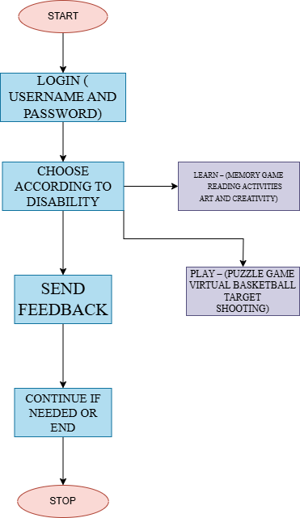

2

# CHAPTER 3

**KEY PHASES OF DESIGN THINKING**

* 1. **EMPATHIZE**

Understand the unique needs of children with disabilities by observing and interacting with them in their environments. Engage with parents, caregivers, and educators to learn about challenges and desires. Conduct interviews or surveys to gather insights about their experiences and aspirations.

* 1. **DEFINE**

Define the core problem: children with disabilities often face barriers to inclusive learning and play opportunities. Specify objectives: ensure accessibility, promote engagement, and address diverse needs. Clearly articulate the goals: create an adaptive, user-friendly, and enjoyable learning/play solution. Focus on inclusion to foster a sense of belonging.

* 1. **IDEATE**

Brainstorm creative solutions like sensory-rich play equipment, adaptive learning apps, or inclusive game sets. Collaborate with specialists to design diverse and engaging activities. Emphasize solutions that foster social interaction among all children. Prioritize affordability and scalability for widespread use.

* 1. **PROTOTYPE**

Develop a prototype, such as a modular learning kit, inclusive playground model, or adaptive app. Ensure it incorporates accessibility features like large buttons, audio instructions, and tactile feedback.

3

* 1. **TEST**

Conduct usability tests with children, parents, and caregivers in a real-world setting. Gather qualitative and quantitative feedback to assess effectiveness and engagement. Observe interactions to identify areas for improvement in accessibility or design.

4

# CHAPTER - 04 MODULE DESCRIPTION

* 1. **DASHBOARD MODULE**

Purpose: Central hub for navigation, progress tracking, and personalization.

Features:

* + - User profiles for children, caregivers, and educators.
    - Progress tracking: Displays milestones, achievements, and areas for improvement.
    - Accessible interface with customizable themes, fonts, and colors to cater to different visual or cognitive needs.
  1. **: SENSORY PLAY MODULE**

Purpose: Enhance sensory skills through interactive activities. Features:

* + - Visual stimulation: Games with vibrant colors, patterns, and animations.
    - Auditory activities: Sounds, music, and voice interactions for auditory development.
    - Tactile engagement (with external devices): Activities

prompting physical responses like tapping or swiping.

* 1. **: COMMUNICATION MODULE**

Purpose: Support children with communication challenges, including non-verbal learners.

Features:

* + - Picture Exchange Communication System (PECS): Virtual cards for expressing needs or emotions.
    - Speech-to-text and text-to-speech options.
    - Visual storytelling: Build stories with pictures and captions.
  1. **: COGNITIVE DEVELOPMENT MODULE**

Purpose: Develop problem-solving, memory, and critical thinking skills. Features:

* + - Puzzles: Jigsaws, matching games, or sequencing tasks.
    - Memory games: Matching cards or objects.
    - Cause-and-effect activities: Interactive buttons triggering animations or sounds.

6

* 1. **: ACCESSIBILITY & ASSISTIVE TECHNOLOGY**

Purpose: Ensure the app is usable by children with diverse abilities. Features:

* + - Integration with assistive devices (e.g., eye-gaze trackers, switches).
    - Alternative inputs: Voice commands, gesture recognition, or touch-free controls.
    - Multiple language and auditory support options.

7

# CHAPTER - 05 CONCLUSION

The proposed app for learn/play for children with disabilities aims to bridge the gap between traditional learning methods and the diverse needs of children with cognitive, physical, and sensory challenges. By integrating adaptive modules that prioritize inclusivity, accessibility, and engagement, the app can foster holistic development—enhancing cognitive, social, emotional, and physical skills.

Through its tailored learning paths, gamified experiences, and assistive technology integration, the app empowers children to explore, learn, and grow at their own pace. At the same time, it provides valuable support to caregivers and educators by offering insights, resources, and actionable feedback.

This initiative not only promotes inclusive education and play but also contributes to building a more equitable world where every child, regardless of ability, can thrive and reach their full potential. By prioritizing innovation, empathy, and accessibility, this app can serve as a model for future advancements in learn/play technologies for children with disabilities.

Would you like assistance refining this conclusion or tailoring it for a specific audience (e.g., funding proposals, educational institutions).

8

# REFERENCES:

**BOOKS:**

1. **Adams, Richard** - *Games for Children with Special Needs* (Book focused on inclusive activities).
2. **Batshaw, Mark L., et al.** - *Children with Disabilities*

(Comprehensive reference on child disabilities).

1. **Clements, Rhonda L.** - *Therapeutic Play Activities for Children*

(Guide to play therapy techniques).

# WEBSITES:

1. [**Child Development Institute**](https://childdevelopmentinfo.com/)- Articles and tools for child development, including for children with disabilities.
2. [**Inclusive Play**](https://inclusiveplay.com/)- Guidance and products for creating accessible play environments.
3. [**Understood.org**](https://www.understood.org/)- Resources for learning disabilities and play strategies.

# YOUTUBE CHANNELS:

1. **Adaptive Play Solutions** - Demonstrations of adaptive toys and play setups for children with disabilities.
2. **Ability Life Solutions** - Features activities and tips for children with physical and cognitive challenges.

9

# APPENDIX A – SCREENSHOTS

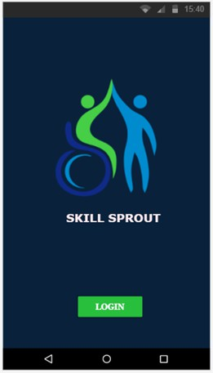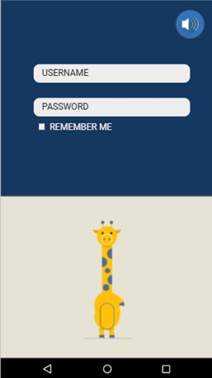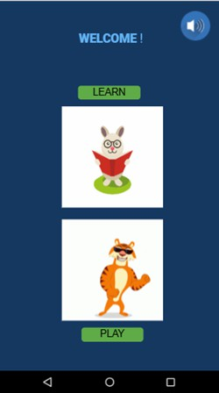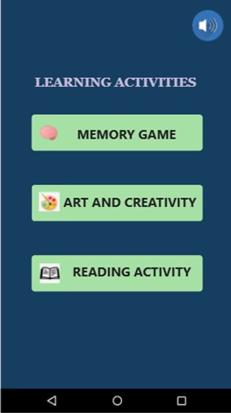

10

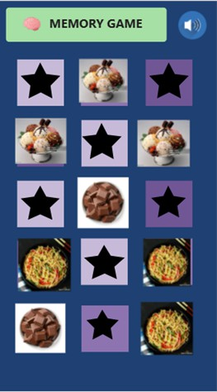 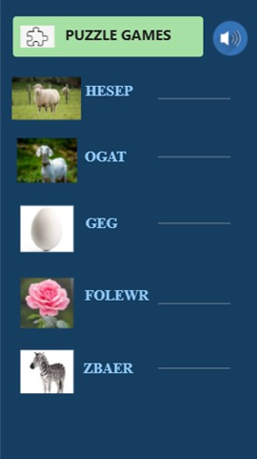

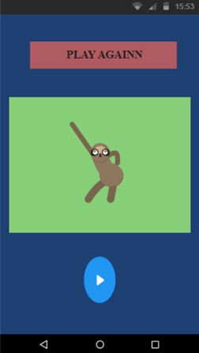

11